**11.AWS-EC2-Reserved-Scheduled-AMIs**

**Reserve instances**

If you have a 1yr or 3years project and need 5 compulsory data base servers. You can purchase these servers for 1yr or 3years for cheap price if you reserve those servers.

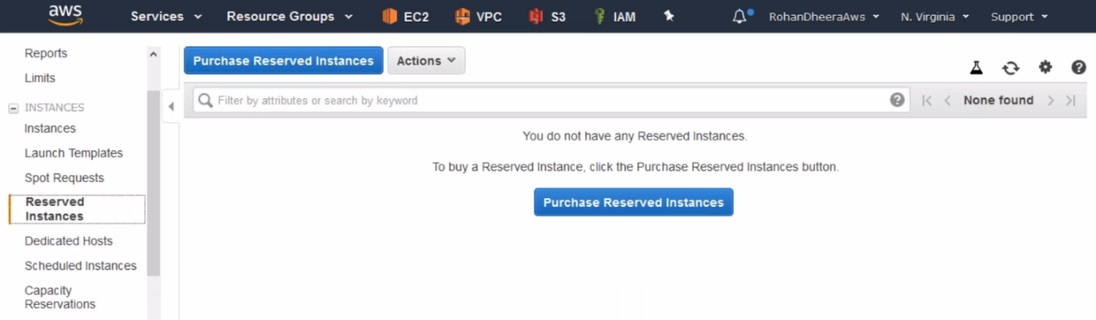

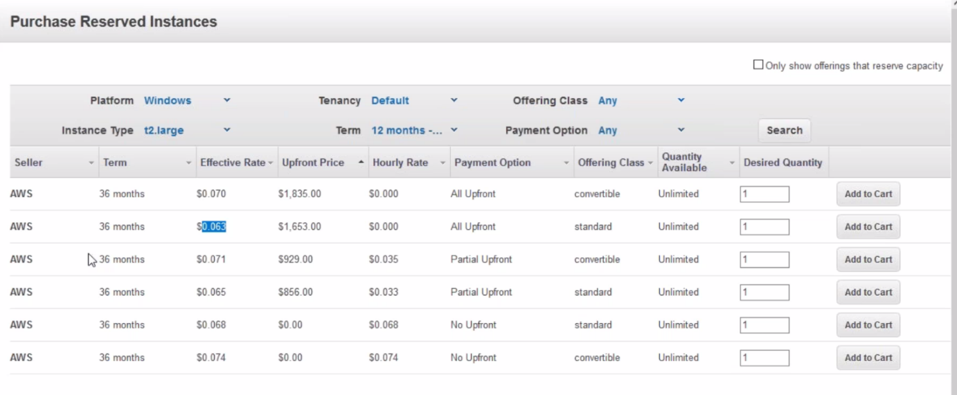

--- here 2types 1. convertible – we can convert after purchasing to t2,t3…etc

2. standard – fixed we can’t change once purchased.

**Scheduled Instance’s**

We can purchase scheduled instances on weekly basses and daily basses.

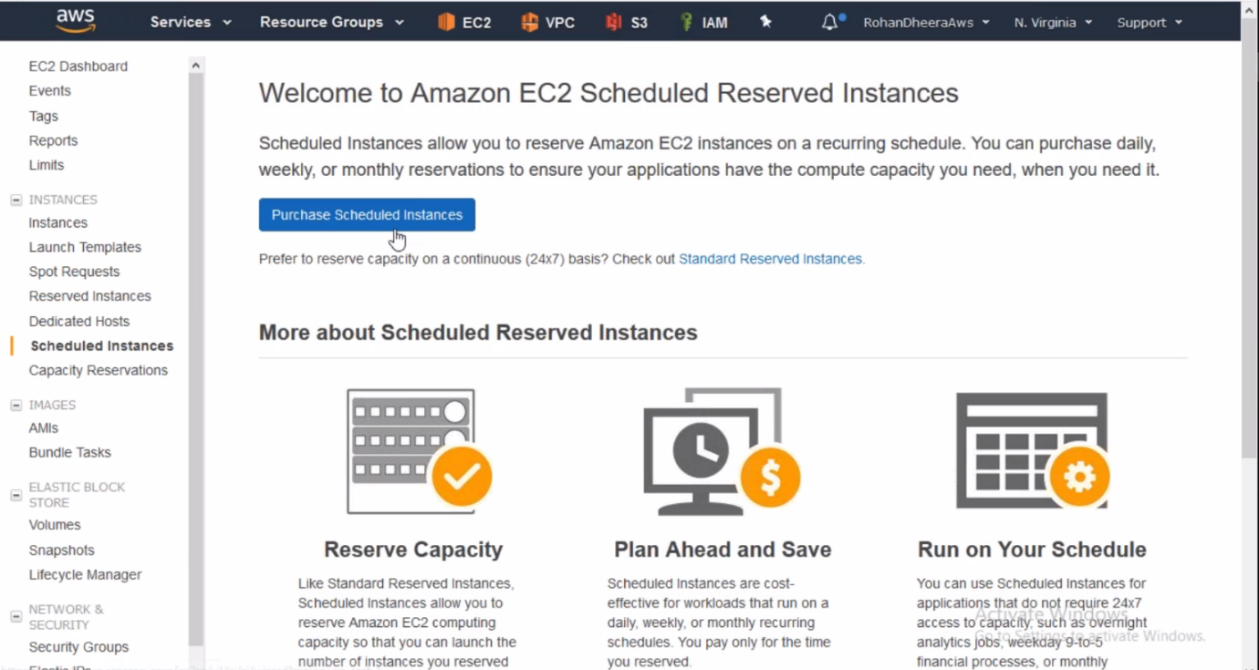

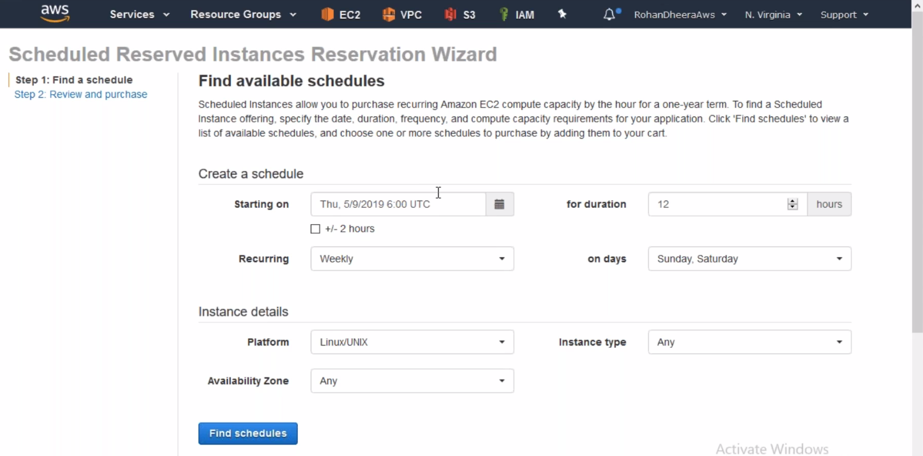

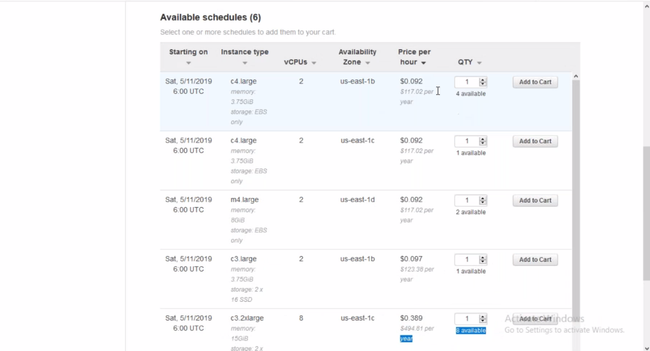

**Capacity Reservation’s**

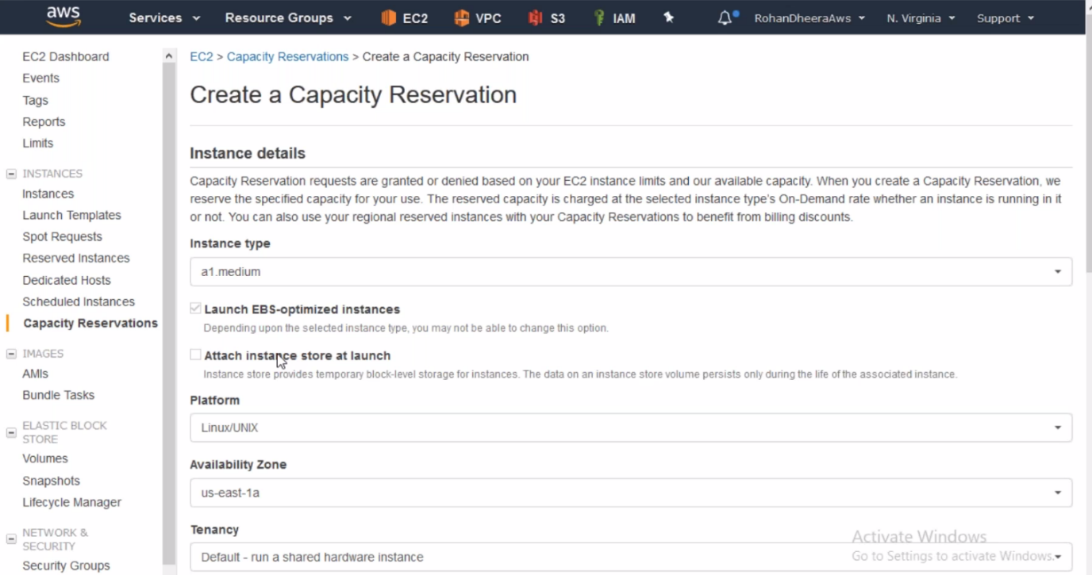

**AMIs**

The AMI’S will change with respective to region or location

Ami is image, it is just template

Ec2 instance 🡪 snapshot 🡪 AMI

**Ami creating from instance**

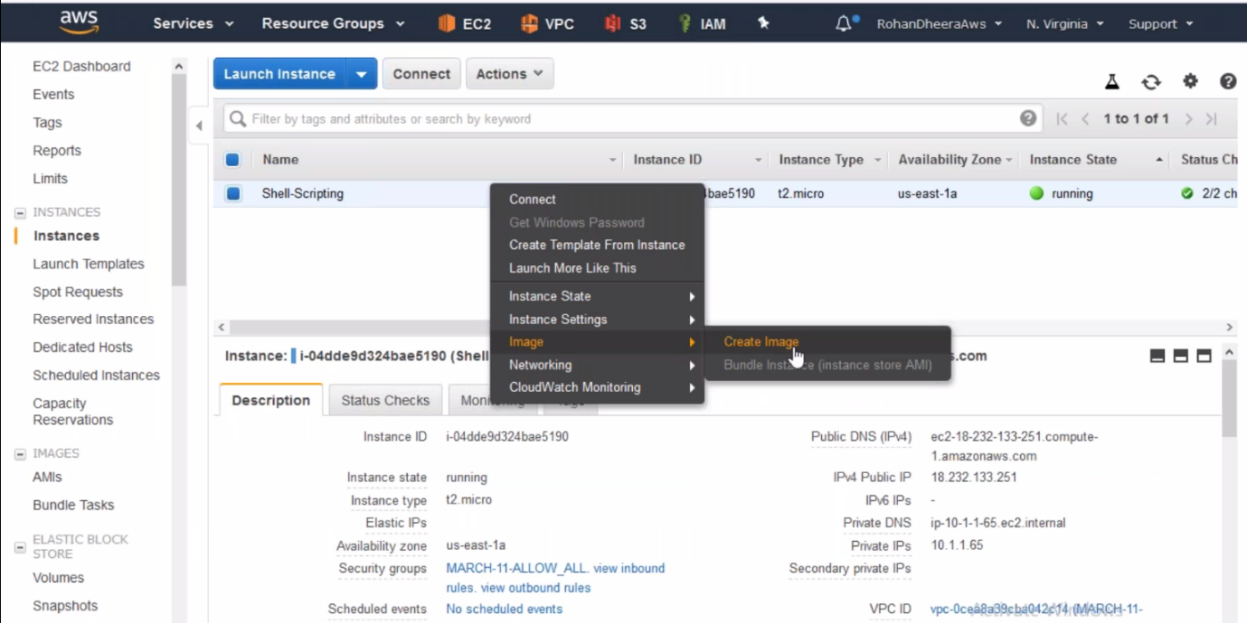

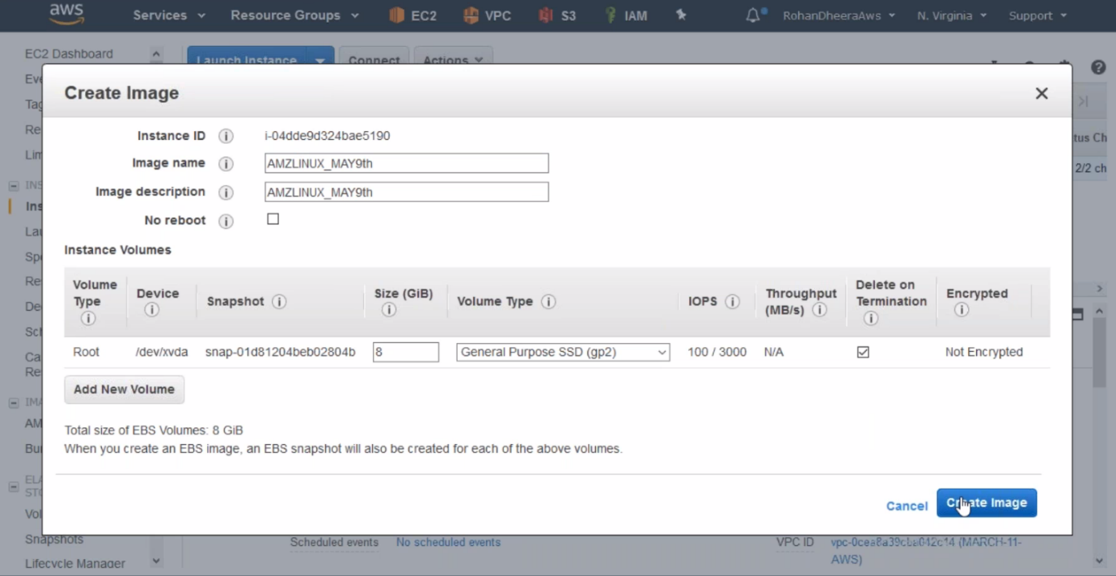

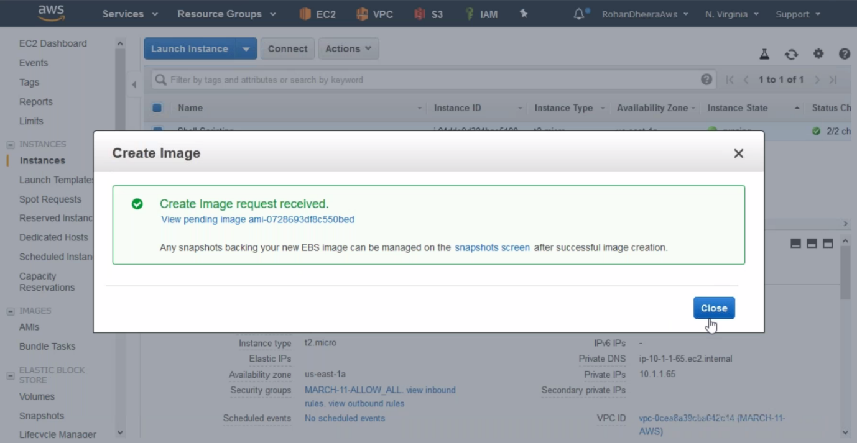

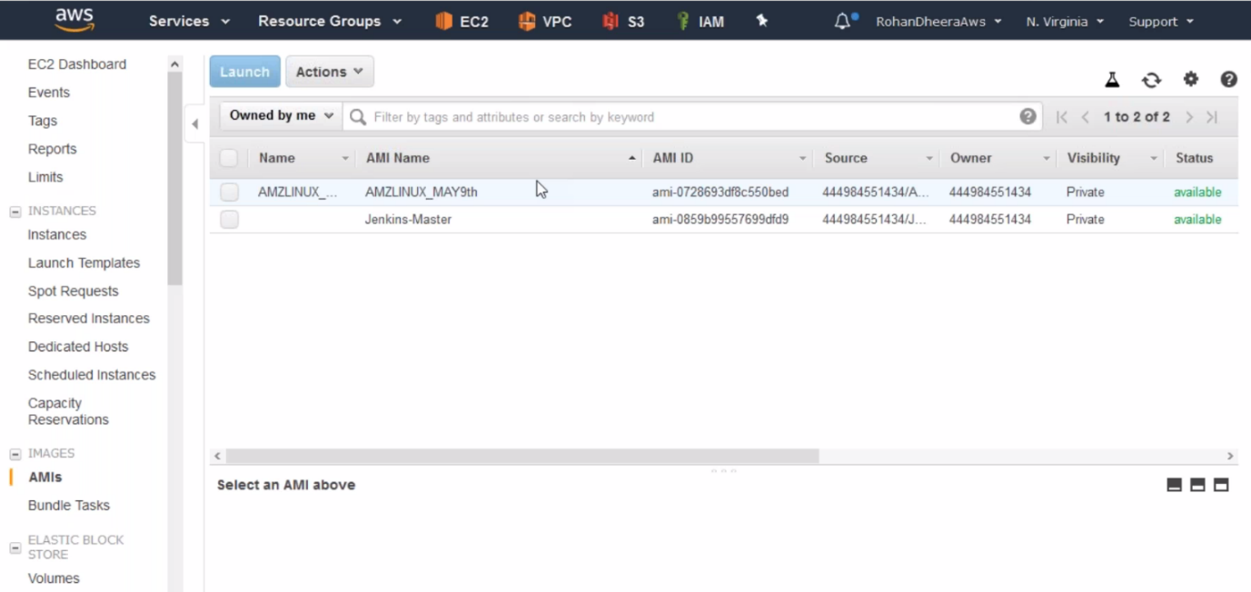

--- AMI is created successfully.

**Copying AMI to the other region or location**

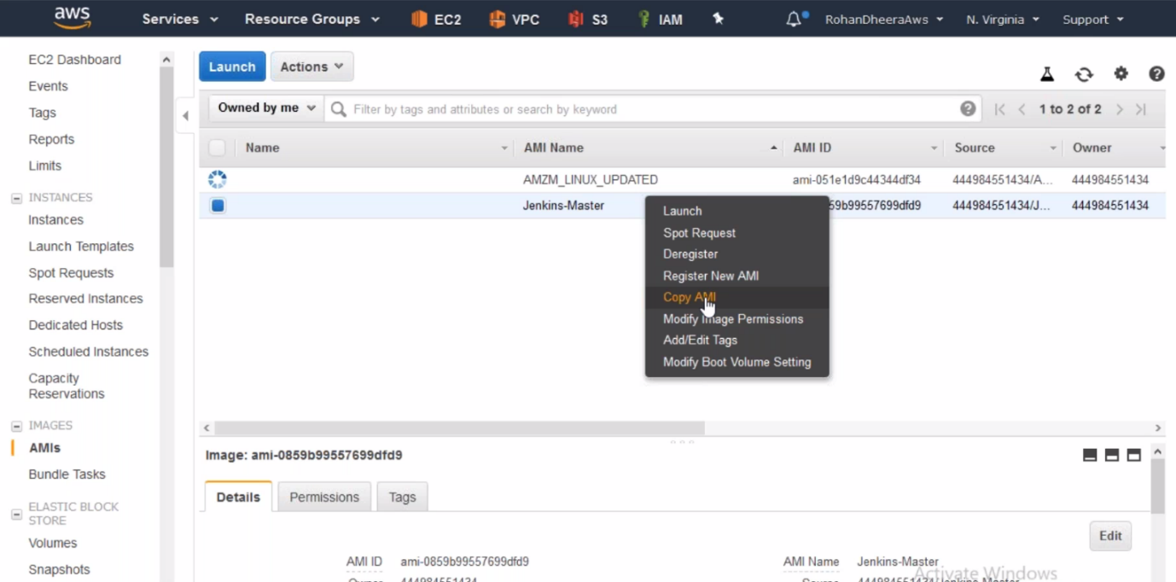

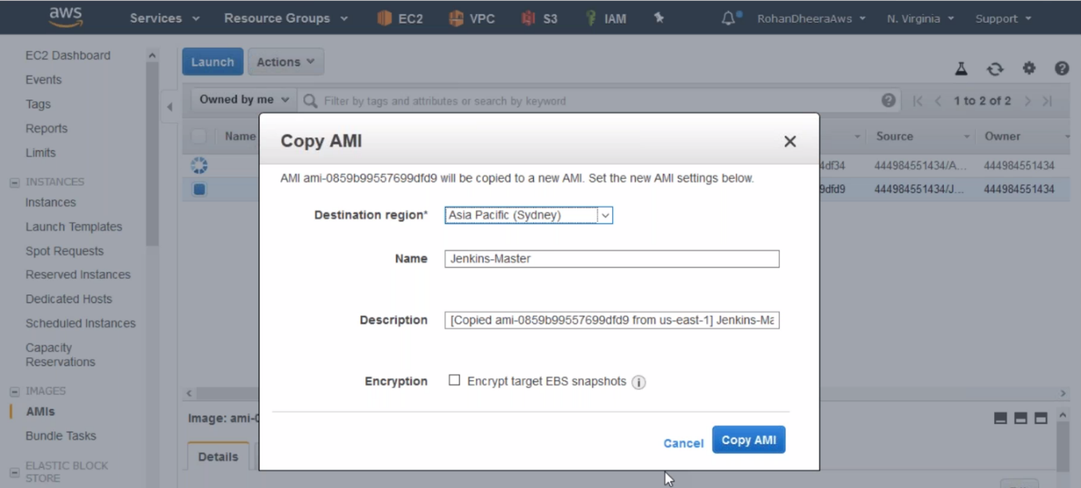

**Copying AMI to the other AWS account**

